



 nodal balance

**** existing branch flow

 candidate branch flow

**** existing line flow limit

 candidate line flow limit

 pseudo generator line relationship

 pseudo generator limit

 generator limit

 slack variable 1

 slack variable 2

installation status maintains constraint

 status change constraint

 reference bus angle

(parameter): investment cost of transmission line k

(Decision Variables) : installation status change indicator of line k in year t. When transmission line status changes, it equals to 1. Otherwise, it equals to 0.

(parameter): discount rate. According to “Market-Based Coordinate of Transmission and Generation Capacity Planning” page 10, it sets to be 5%.

(parameter): set of prospective lines.

(parameter): total planning years

(parameter): total operating years

(parameter): set of generators

(parameter): Duration in year t, which is 8760 hours.

(parameter): Hourly energy cost of generator g in year t.

(Decision Variables): Dispatched capacity of generating unit g in year t.

(parameter): Capacity factor of generator g in year t.

(parameter)****: Nodal balance violation penalty vector

(parameter)****: Nodal balance violation penalty vector

(Decision Variables)****: Bus slack variable vector

(Decision Variables)**** : Bus slack variable vector

(parameter): bus branch incidence matrix for existing line

(parameter): bus branch incidence matrix for candidate line

(parameter): bus branch slack variable matrix

(parameter): bus real generator/ pseudo generator incidence matrix

(parameter): bus load incidence matrix

(parameter) : bus real generator/ pseudo generator incidence matrix

(Decision Variables): existing line/ candidate line branch flow vector

(parameter): load in the year t

(Decision Variables) : real generator/ pseudo generator vector

(Decision Variables): bus voltage angle vector

(parameter): existing/ candidate branch reactance matrix

(parameter): big value

(Decision Variables): transmission line decision variable vector

(Decision Variables): Binary decision variable for a prospective line k in year t, which consist the transmission line decision variable vector .

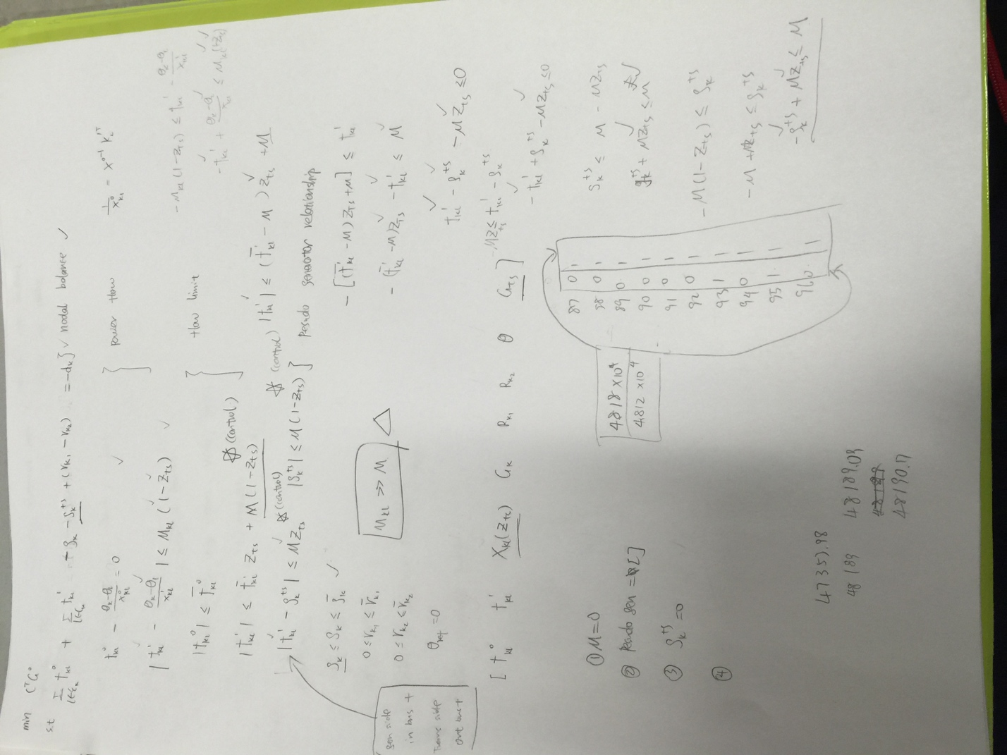

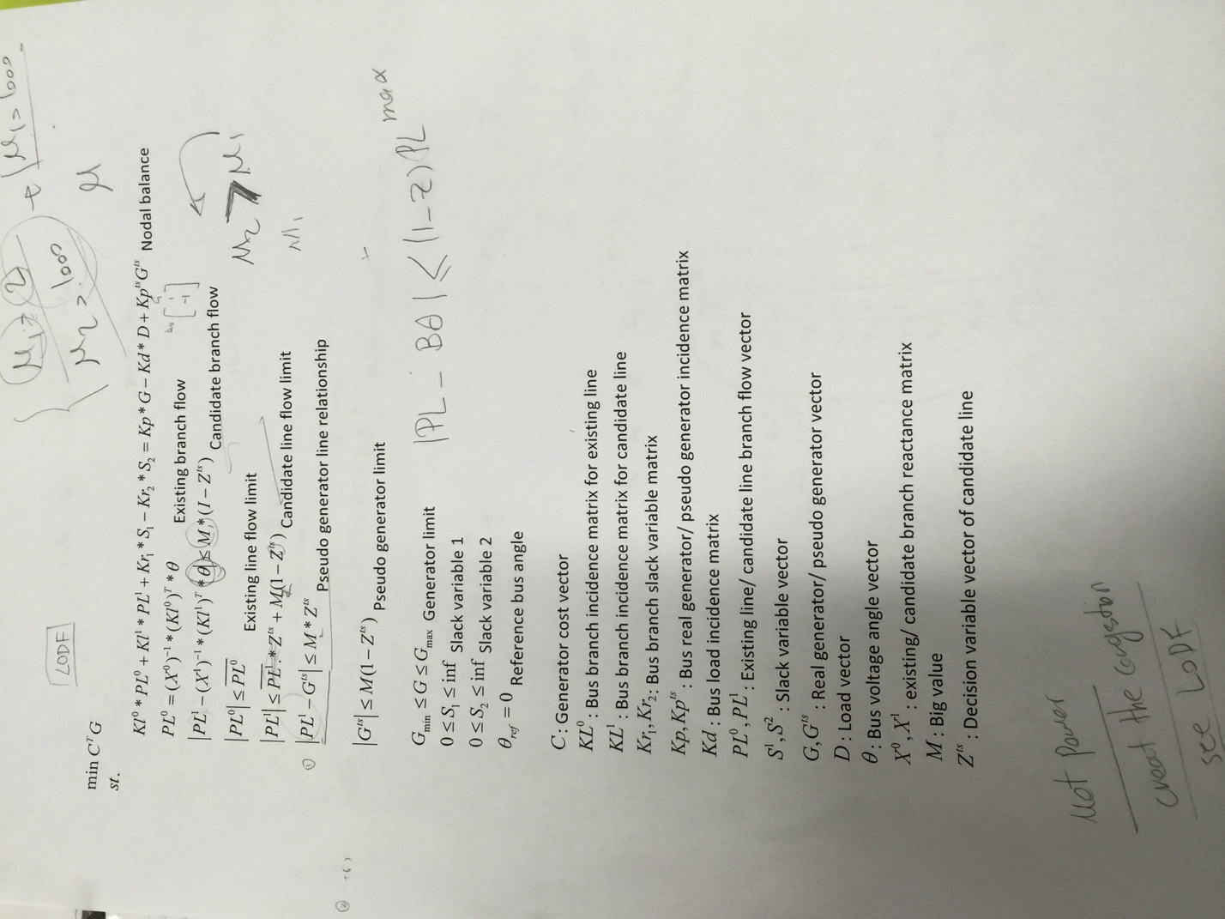

Pseudo generator model:

Number of Inequality: 30270

Number of equality: 4560

Number of variable: 17280

Number of continuous variable: 11700

Number of binary variable: 5580

Line status model:

Number of Inequality: 19110

Number of equality: 4560

Number of variable: 14490

Number of continuous variable: 8910

Number of binary variable: 5580